AI Research Assistant Platform
Problem Analysis & Workflow Documentation
Summer School '26 — n8n Capstone Project

1. Problem Analysis

1.1 Business Context
Anyone who has spent time doing research work knows the routine: you find a topic you care about, and then you're stuck checking arXiv or Google Scholar every few days hoping something new and relevant has shown up. Most of the time it hasn't, and when it has, you still have to read through the abstract, decide if it's worth your time, and then actually read the paper before you know if it was useful at all. Multiply that across five or six active research interests and it turns into a part-time job just to stay updated.
Researchers, faculty members, and students all run into this in slightly different ways, but the core issue is the same — there's no system doing this tracking and filtering for them automatically. Everything depends on someone remembering to go check, and that doesn't scale well once a person is juggling coursework, projects, or their own publishing deadlines.
This project builds a small AI-powered platform on n8n that takes over that repetitive tracking-and-summarizing work, so the person on the other end just has to register their interests once and then check their inbox once a week.

1.2 Stakeholders
- Students and researchers who want to stay current in their field without manually searching databases every day.
- Faculty members who supervise multiple research areas and don't have time to track publications across all of them.
- Whoever eventually maintains this system (in this case, me) — needs it to run reliably without constant babysitting once it's deployed.

1.3 Pain Points
- Manually searching arXiv, Semantic Scholar, or Google Scholar for new papers is repetitive and easy to forget to do consistently.
- Reading full abstracts (or worse, full papers) just to judge relevance wastes a lot of time when most papers turn out to be only tangentially related.
- There's no single place to keep track of papers once you've found them — they end up scattered across browser tabs, bookmarks, or half-finished notes.
- Without a recurring reminder or digest, it's easy to miss papers that were published exactly when you happened to be busy with something else.

1.4 Objectives
Directly from the assignment brief, adapted to how this project actually implements them:
- Automate literature collection — search academic sources automatically instead of manually.
- Generate AI-powered research summaries so a person can judge relevance in a few seconds instead of a few minutes.
- Organize references into a searchable repository instead of scattered bookmarks.
- Track new publications automatically on a recurring schedule.
- Maintain a running research knowledge base that grows on its own over time.

1.5 Solution Overview
The platform is built as five independent n8n workflows that share a common Google Sheet as their backing data store. A user registers their research interests once through a Google Form; from there, the system runs on its own — searching arXiv daily, summarizing new papers with an LLM (Groq's Llama 3.3 70B), organizing them into categories and a running repository document, and sending out a personalized weekly digest email. Each workflow does one job and hands off to the next through the shared sheet, rather than being tightly wired together, which made it much easier to build, test, and debug one piece at a time.
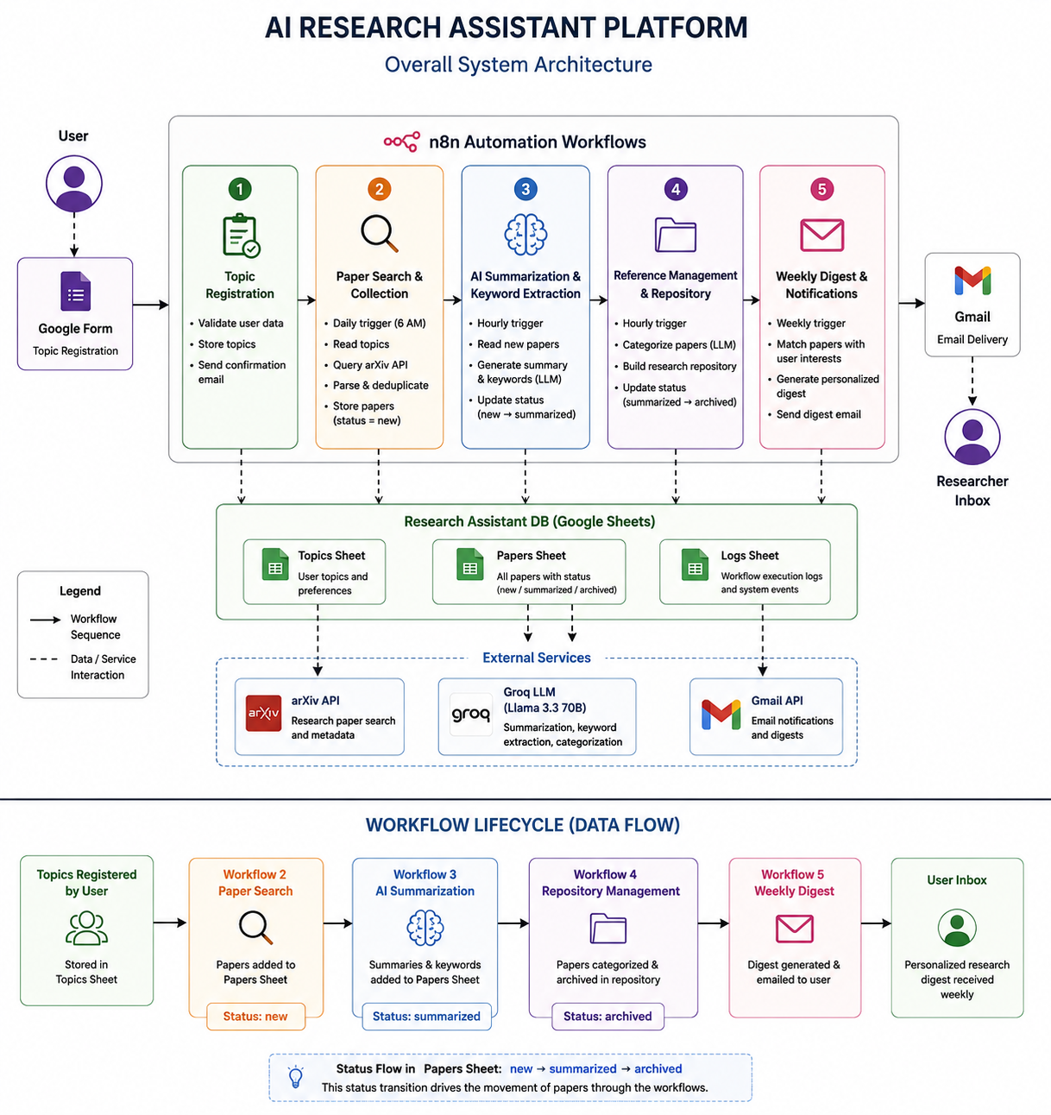

2. Workflow Architecture

2.1 Overall System Architecture
The system consists of five separate n8n workflows, each exported and stored as its own JSON file. They are deliberately loosely coupled — rather than one workflow directly calling the next, they communicate through a shared Google Sheet (“Research Assistant DB”) with three tabs: topics, papers, and logs. Each workflow reads whatever it needs from this sheet, does its job, and writes its results back, tagging rows with a status field (new → summarized → archived) so the next workflow in the chain knows what's ready for it.
This design was a deliberate choice over chaining workflows with n8n's Execute Workflow node. If one workflow fails or is paused, the others keep running independently instead of the whole pipeline breaking down, and it made testing each workflow in isolation far simpler during development.

2.2 Workflow Interaction Diagram
At a glance, data flows in one direction through the pipeline:
- Workflow 1 writes new rows into the topics tab.
- Workflow 2 reads topics, searches arXiv for each one, and writes new rows into the papers tab with status = new.
- Workflow 3 reads papers where status = new, summarizes them with Groq, and updates those rows to status = summarized.
- Workflow 4 reads papers where status = summarized, categorizes them with Groq, appends them to a Google Doc repository, and updates status to archived.
- Workflow 5 reads topics and papers weekly, matches papers to each user's interests, and emails a digest — skipping anyone with no new matches that week.



2.3 Event Flow Between Workflows
None of these workflows call each other directly — each one runs on its own trigger (a form-linked sheet trigger for Workflow 1, and scheduled cron triggers for Workflows 2 through 5) and simply checks the shared sheet for work that's ready for it. This is closer to an event-driven design than a strict pipeline: the “event” is really just a status flag changing on a row, and the next workflow's schedule eventually picks it up. It's not instantaneous, but for a research digest tool that's perfectly fine — nobody needs their paper search results the same second a new topic is registered.

3. Workflow Documentation
Each of the five workflows below is documented with its trigger, its full node sequence, the reasoning behind key decisions, and any AI/LLM logic involved. Screenshots and exported JSON files for each workflow are referenced separately in the GitHub repository.

3.1 Workflow 1 — Research Topic Registration
This is the entry point of the whole platform. A user fills out a short Google Form telling the system what research topics and keywords they want tracked. n8n picks up the new submission, cleans up the data, stores it in the shared sheet, and sends the user a confirmation email so they know they're registered.

Trigger
Google Sheets Trigger, polling every minute, watching for new rows added to the Google Form's linked response sheet.

Node sequence
Step | Node | What it does
1 | Google Sheets Trigger | Watches the form-response sheet and fires whenever a new row (i.e. a new form submission) appears.
2 | Edit Fields (Set) | Cleans up the raw form fields into consistent keys — name, email, topic, user_id, date_registered — and lowercases/trims the topic text.
3 | IF | Checks that email and topic aren't empty before continuing, so a malformed or partial submission doesn't get stored.
4 | Google Sheets — Append Row | Writes the cleaned record into the topics tab of the Research Assistant DB sheet.
5 | Gmail — Send | Sends the user a short confirmation email letting them know what topic they've been registered for.

Notes
The original form design had two separate fields for “topic” and “keywords,” but since both ended up holding identical data in testing, they were merged into a single topic field to avoid redundant columns. A cleaner version of this system could split them again — a broad category field plus a separate free-text keyword field — but for the scope of this project, one field was simpler and worked fine.

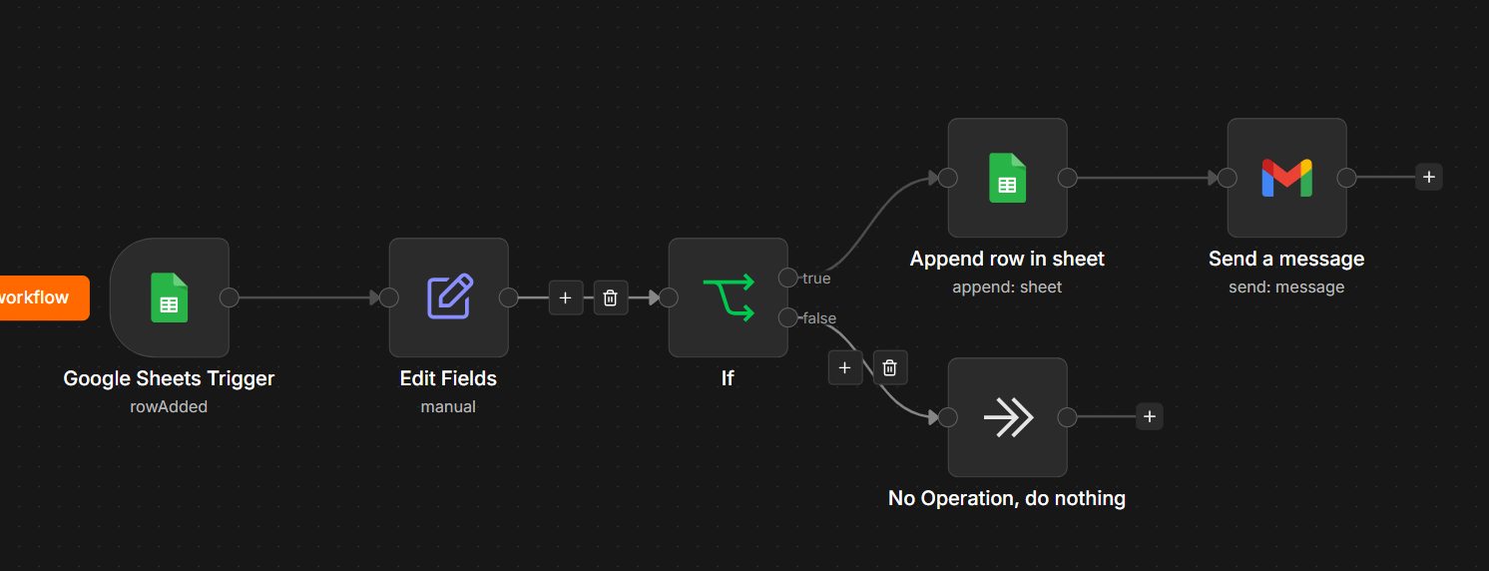

3.2 Workflow 2 — Paper Search & Collection
This workflow runs once a day, goes through every registered topic, and searches arXiv for recently published papers matching that topic. It's the workflow that actually populates the papers tab that the rest of the pipeline depends on.

Trigger
Schedule Trigger, once daily at 6:00 AM.

Node sequence
Step | Node | What it does
1 | Schedule Trigger | Fires once a day to kick off the search.
2 | Google Sheets — Get Rows | Reads every registered row from the topics tab.
3 | Loop Over Items | Processes one topic at a time (batch size 1), so each arXiv query stays isolated and easy to debug.
4 | HTTP Request | Calls arXiv's public API (export.arxiv.org/api/query) with the topic as the search term, sorted by newest submissions.
5 | Code (JavaScript) | arXiv returns Atom XML rather than JSON, so this node regex-parses out the title, authors, abstract, link, and publish date for each entry into clean objects.
6 | Code (JavaScript) — Deduplicate | Once all topics have looped through, removes duplicate papers (by paper ID) that may have matched more than one topic, and stamps each one with status = new and a collection timestamp.
7 | Google Sheets — Append Row | Writes each unique new paper into the papers tab.

Notes on Semantic Scholar
The original plan (and the assignment's suggested integration list) included Semantic Scholar as a second source alongside arXiv. During development, Semantic Scholar's public unauthenticated endpoint returned repeated 429 “too many requests” errors, and their free API key application form kept rejecting a valid institute email address for reasons that were never fully clear. Rather than let that block the rest of the build, the Semantic Scholar branch was removed for this submission and arXiv alone was kept as the working source. The workflow was designed so this branch can be re-added later — a Wait node plus retry settings would be enough to add it back in cleanly once a key comes through, and this is noted as a future improvement rather than a missing feature.

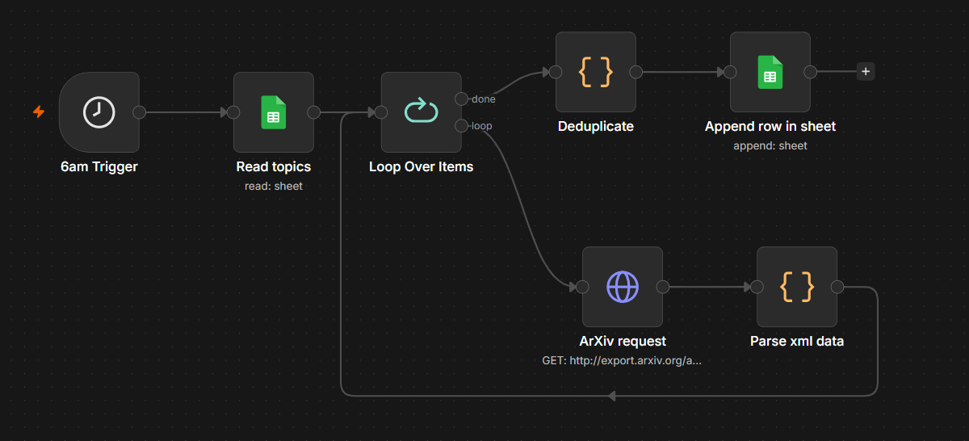

3.3 Workflow 3 — AI Summarization & Keyword Extraction
This is the workflow that actually uses AI to do something useful with the raw papers Workflow 2 collected — turning a dense abstract into a short, readable explanation and a handful of keywords, so a user can judge relevance without reading the whole thing.

Trigger
Schedule Trigger, running hourly, to catch new papers shortly after Workflow 2 has run (this also means the workflow self-corrects if a run gets delayed for any reason).

Node sequence
Step | Node | What it does
1 | Schedule Trigger | Fires hourly.
2 | Google Sheets — Get Rows (filtered) | Reads only rows from the papers tab where status = new.
3 | Loop Over Items | Processes one paper at a time (batch size 1).
4 | Basic LLM Chain + Groq Chat Model | Sends the paper's abstract to Groq (llama-3.3-70b-versatile) with a prompt asking for a 3-sentence plain-language explanation and 5 keywords.
5 | Structured Output Parser | Forces the model's response into a fixed JSON shape (summary as a string, keywords as an array), so the next node doesn't need to manually parse or guess at the format.
6 | Edit Fields | Flattens the parsed output into simple summary and keywords fields, joins the keyword array into a comma-separated string for the sheet, and sets status = summarized.
7 | Google Sheets — Update Row | Matches the row by paper_id and writes the summary, keywords, and updated status back into the papers tab.

Prompt used
You are a research assistant helping a student quickly understand a paper.
Title: {{ $json.title }}
Abstract: {{ $json.abstract }}
Write a natural, flowing 3-sentence explanation of this paper for someone
skimming research in this field. Vary your sentence structure and opening
phrases each time — do not start with "This paper solves" or use the phrase
"key takeaway." Write as if explaining it casually to a colleague, focusing
on what makes THIS paper's approach distinct from typical work in its area.
Also extract 5 relevant keywords.
Respond with ONLY valid JSON in this exact format, no markdown, no code
fences: {"summary": "...", "keywords": ["kw1", "kw2", "kw3", "kw4", "kw5"]}

A design decision worth explaining
The first version of this prompt asked the model directly for “what problem it solves, what's novel, and one takeaway” — structurally, this produced summaries that all read identically regardless of the actual paper, because the model was just filling in the same three-part template every time. Rewriting the prompt to explicitly ban that phrasing and ask for natural, varied sentence structure fixed this almost completely — a good reminder that with LLMs, the shape of your instructions ends up shaping the output just as much as the content does.

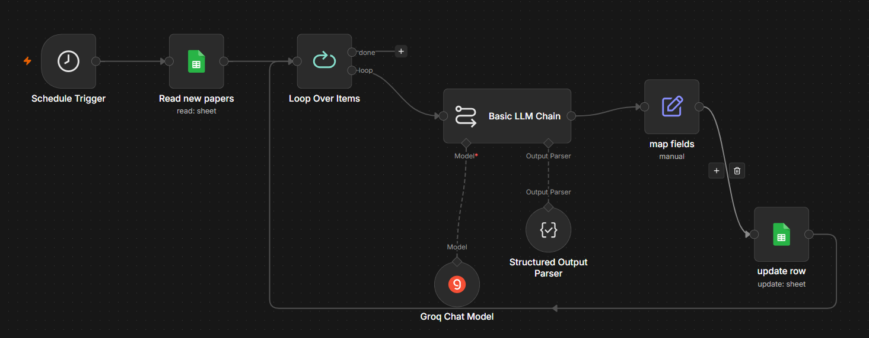

3.4 Workflow 4 — Reference Management & Repository
Once a paper has been summarized, this workflow gives it a category tag and files it into a running Google Doc that acts as the project's searchable repository — the place a user (or the person maintaining this system) could scroll through or Ctrl+F to find past papers by topic.

Trigger
Schedule Trigger, running hourly.

Node sequence
Step | Node | What it does
1 | Schedule Trigger | Fires hourly.
2 | Google Sheets — Get Rows (filtered) | Reads rows from papers where status = summarized.
3 | Loop Over Items | Processes one paper at a time.
4 | Basic LLM Chain + Groq Chat Model | Given the paper's title, keywords, and summary, asks the model to assign one broad category (e.g. AI/ML, NLP, Security) rather than maintaining a hardcoded keyword-to-category mapping by hand.
5 | Structured Output Parser | Parses the model's response into a clean category field.
6 | Edit Fields | Sets status = archived alongside the assigned category, and carries the paper_id forward for the row update.
7 | Google Sheets — Update Row | Writes the category and archived status back to the matching row in papers.
8 | Google Docs — Insert Text | Appends a formatted entry (category, title, authors, summary, link, and a divider) to the end of the Research Repository document.

Why AI categorization instead of a fixed rule list
An earlier version of this workflow used a hardcoded list of keywords mapped to category buckets. That works fine at first, but it means every time a user registers an interest that doesn't fit the existing buckets, someone has to go back and edit the code. Letting Groq assign a category based on the paper's actual content removes that maintenance burden entirely and scales to topics nobody anticipated when the buckets were first written.

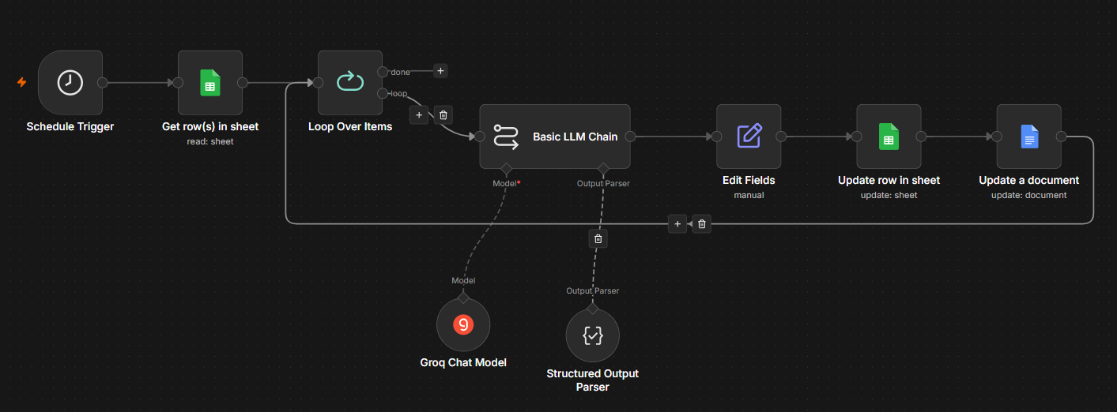

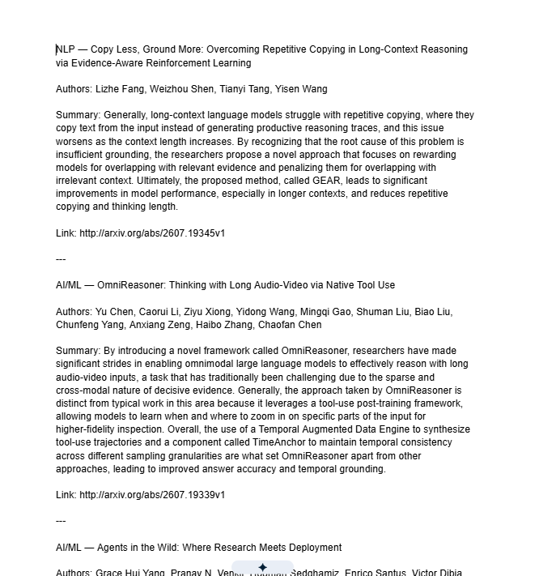

3.5 Workflow 5 — Weekly Digest & Notifications
This is the payoff workflow for the whole platform — once a week, every registered user gets a personalized email listing the papers found for their topic over the past seven days, with an AI-written intro paragraph and a clean list of summaries and links below it.

Trigger
Schedule Trigger, weekly (Monday morning).

Node sequence
Step | Node | What it does
1 | Schedule Trigger | Fires once a week.
2 | Google Sheets — Get Rows | Reads every registered user from the topics tab.
3 | Loop Over Items | Processes one user at a time.
4 | Google Sheets — Get Rows (filtered) | Reads all archived papers.
5 | Code (JavaScript) | Filters that full paper list down to only the ones matching this specific user's topic keywords and collected within the last 7 days. If nothing matches, the item is dropped here and no email gets sent to that user this week.
6 | IF | Confirms at least one matching paper was found before continuing to the AI/email steps.
7 | Basic LLM Chain + Groq Chat Model | Writes a short, warm intro paragraph mentioning how many papers were found this week for the user's topic — deliberately instructed not to write its own greeting or sign-off, since those are added separately in the next step using the real registered name.
8 | Edit Fields | Assembles the final HTML email body: a greeting using the user's actual name, the AI-written intro paragraph, then a formatted list of each paper (bolded title, authors, summary, clickable link).
9 | Gmail — Send | Sends the finished digest to the user's registered email address.

Prompt used
You are writing a friendly weekly research digest email intro for
{{ $json.user_name }}, who is interested in: {{ $json.topic }}
Here are the papers found this week:
{{ $json.papers.map((p, i) => (i+1) + ". " + p.title + " - " + p.summary)
.join("\n\n") }}
Write a warm, concise intro paragraph (2-3 sentences) mentioning how many
papers were found and briefly setting expectations for what's below.
Strict rules:
- You may reference the user's name naturally within the paragraph if it
fits, but do NOT start with a greeting like "Hi [name]" or "Hello [name]"
- Do NOT include any closing line, sign-off, "Best regards", or
"[Your Name]" placeholder at the end
- Do NOT repeat the full paper list — that will be added separately
below your intro
- Output ONLY the paragraph text itself, nothing else

A small but useful lesson from this workflow
The first version of this prompt let the model write the entire email, greeting and sign-off included. It kept inventing things like “Best, [Your Name]” because that's simply how email-shaped text usually ends in its training data — even after being told not to add a greeting. The fix was splitting responsibilities cleanly: the model only ever writes the middle paragraph, and the actual greeting and sign-off come from the workflow's own template using real data from the sheet. It's a small thing, but it's a good example of why it's often safer to let an LLM handle the part that genuinely needs judgment (summarizing) and keep the predictable, data-driven parts (names, links, formatting) outside of it.

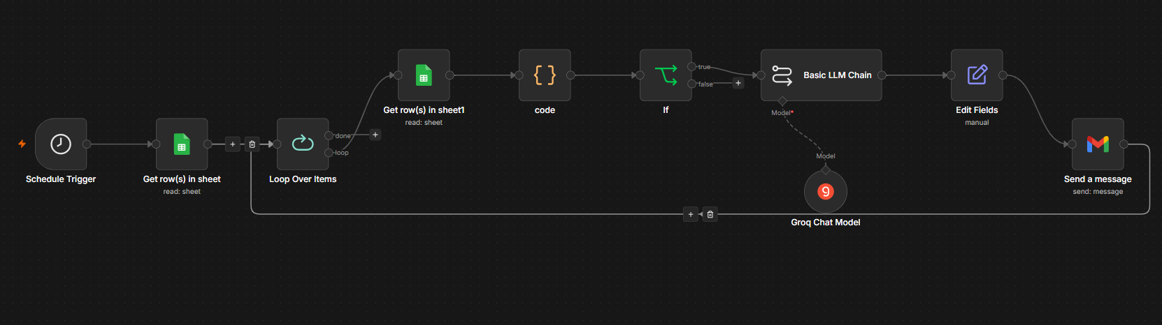

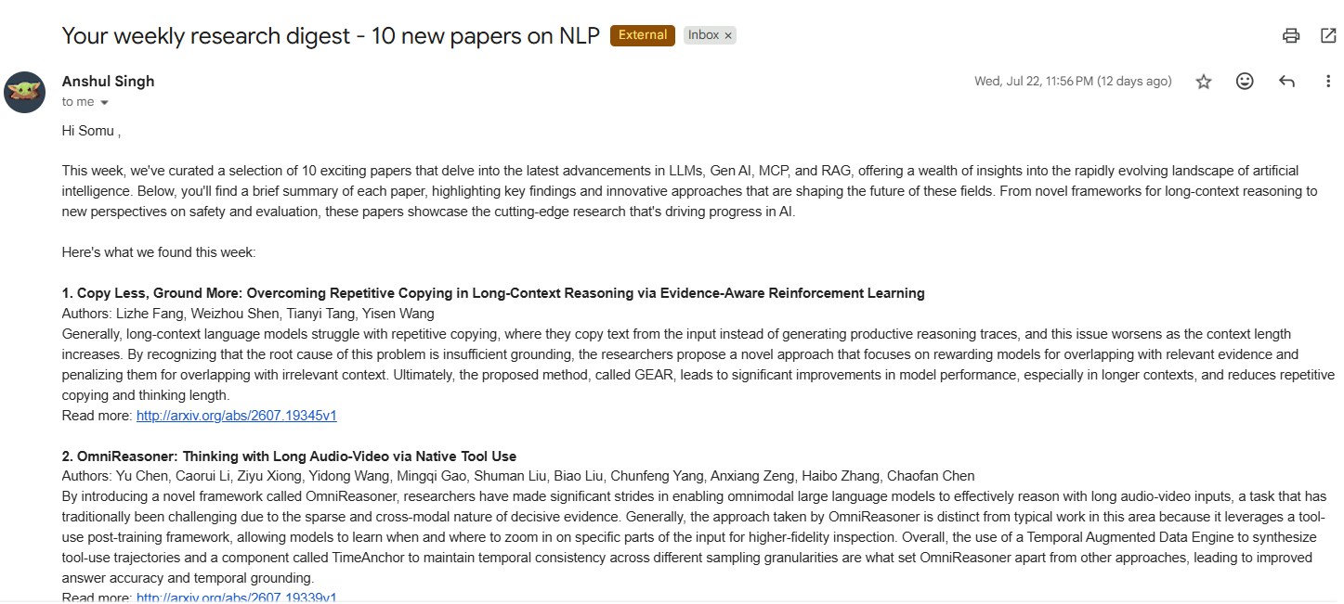

4. Known Limitations & Future Improvements
- Semantic Scholar was dropped as a second paper source due to rate-limiting and an API key application that repeatedly failed email validation. arXiv alone currently powers all paper discovery.
- Topic and keyword are currently the same field on the registration form; splitting them into a broad category plus specific keywords would allow more precise digest matching.
- The repository is a single running Google Doc rather than a proper searchable database — fine at this scale, but a real search index (or even just a filtered Google Sheet view) would hold up better as the paper count grows.
- There's currently no human-approval step before a paper is archived or a digest is sent; adding an optional approval gate (e.g. via Slack or a reply-to-confirm email) was considered but left out to keep the pipeline fully automated for the demo.

